Sameh Abdellal
Professor Velez
English
November 22, 2020

Objective Complete!

I look back to the beginning of the semester and I immediately notice no change. I recall the same thing happening the previous semester and the one before that and so on. I then think about how much I progressed from the beginning, from the first day of kindergarten to now. I realize that I mentally grew a tremendous amount and that it could not have happened in one night. It happened through each lesson, homework assignment, and even essays. When I start to evaluate my mental growth over this semester that is nearing the end, I think about all the class lessons I sat through, all the homework I completed, and all the essays I wrote. This semester, I learned many of the intended learning objectives to a great extent.
This English semester was extremely organized. It was divided up into four sections where each section taught us new objectives and even reiterating some of the learned objectives. During the first phase of the course we read many works that talked about a type of discrimination that I did not hear about before: dialect discrimination. We then had various homework assignments where we wrote about the articles so that we could further understand the theme of them. We then concluded the phase by writing our own literacy narrative and presenting our spoken literacy narrative.
This phase taught me one of the learning objectives which is recognizing the roles of language attitudes and standards in empowering, oppressing, and hierarchizing languages and their users, and being open to communicating across different languages and cultures. What I achieved from this objective is recognizing how “white English” is the correct form of English in the United States and anyone who speaks differently is wrong. I also learned to not discriminate against anyone because of the way they speak, which I may have unintentionally done before. I learned these through the articles Mother Tongue by Amy Tan and Nobody Mean More to Me Than You and the Future Life of Willie Jordan, by June Jordan. Amy Tan explained that dialect discrimination was something her mother had to face on a daily basis. People ignored her at the store and even in a hospital, she was not being treated like an average patient (Tan). Jordan talked about African-American English and how her students were not even taught it. Her article made me feel as if white English is the dominating language and the others are running out of gas. Through these articles I learned that different types of English should be seen more often rather than being discriminated against. During the end of the phase I created a presentation where I presented to my class. Through this and my written essay, I addressed a range of audiences.
In the second phase of this course, we continued with examining the texts we read in the previous phase and we talked about how those texts developed their theme. We talked about their use of rhetorical strategies in getting the theme across to the readers. To do this, we had to learn about who their audience was and we learned how to do that in this phase as well. Finally, we completed the phase by writing a rhetorical analysis essay for 2 sources.
I achieved many learning objectives in this phase. The first objective I achieved is exploring and analyzing, in writing and reading, a variety of genres and rhetorical situations. During class time we were taught what ethos, pathos, and logos are, which we used to analyze the texts in our analysis essay. We also used this information to analyze advertisements and the course texts in groups. This leads to another objective which is engaging in the collaborative and social aspects of writing processes. As groups we did many things. We talked about the rhetorical strategies which cleared it up more for me. We also talked about how the essay should be structured and we revised each other’s essays which helped me in developing new strategies for revising and editing. Throughout the whole process, I learned to recognize and practice key rhetorical terms and strategies when engaged in writing situations. Overall, in this phase I learned a lot about rhetorical strategies that I plan to use in the future when reading and writing.
In the following phase we did something different. This phase was centered on researching and using these sources to create an essay. In class, we saw multiple ways to locate good sources and evaluate the sources. We went onto using these sources to create rhetorical precis’ and synthesis’. The phase ended with the submission of a researched essay.
During the beginning of this phase, I learned all about the library system and how to use it to find good sources for my paper and I also learned how to evaluate the sources. I learned that a source is good if it is from a trusted source or if it is a peer reviewed source and other things as well. After I found sources for my essay and evaluated them, I started to compare and contrast their opinion with opinions of other sources as well as my own. I also included information about the actual source itself, such as the author and the theme. This was all included in my essay. This helped me fulfill the objective of composing texts that integrate my stance. My essay was in MLA format, which incorporated text citations as well as a works cited page. This helped me fulfill the goal of practicing systematic application of citation convention.
Overall, I believe that my writing has progressed over time. For example, my first essay did not include any citations, although I utilized sources. Below is part of the works cited page I created for my phase 3 essay which shows my progression in one of the objectives.
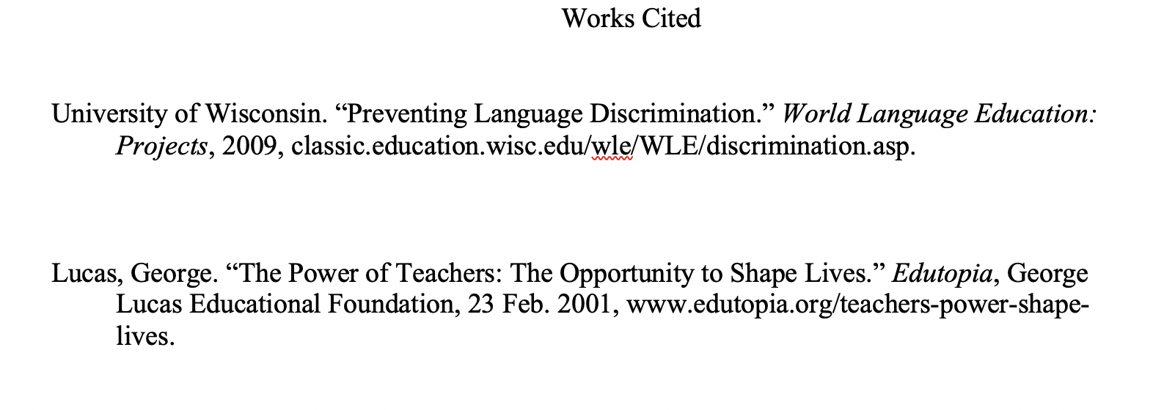
(Abdellal)

Based on this and what I completed throughout this course, I believe that I achieved the course learning objectives to a great extent this semester!

Works Cited
Tan , Amy. “Mother Tongue .” Mother Tongue, www.umsl.edu/~alexanderjm/Mother%20Tongue%20by%20Tan.pdf.
Abdellal, Sameh. Dialect Discrimination . 2020.

